Capstone Project Assignment 4 –
- Data Preparation and Feature Engineering
- Model Exploration

Group -7

Group Members
- May Myat Noe Oo
- Nay Chi Moe Oo
- Min Sett Paing
- Akeri Myint Zaw
- May Phyo Thyu
- Chan Aye Naing

Data Preparation and Feature Engineering

1. Overview
This phase involved collecting, cleaning, and annotating video data to prepare a dataset suitable for training a helmet detection model using YOLOv8. Proper data preparation ensures that the deep learning model learns reliable visual patterns distinguishing riders wearing helmets from those not wearing helmets, contributing to traffic safety monitoring aligned with SDG Goal 3 (Good Health and Well-being).

2. Data Collection
The video data were sourced from Myanmar traffic surveillance footage (e.g., Yangon_II_13) and related open datasets used in previous studies on helmet detection. Frames were extracted at 5–10 FPS using ffmpeg and imported into CVAT and Roboflow for annotation. Each frame was labeled with bounding boxes for two classes:
- helmet
- no_helmet
The annotations were exported in YOLO 1.1 format compatible with YOLOv8.

3. Data Cleaning
Several preprocessing and cleaning steps were applied:
- Removed blurry, low-light, and partially occluded frames.
- Ensured consistency between labels exported from CVAT and Roboflow.
- Verified all bounding boxes to avoid duplicates or misclassified riders.
- Balanced the dataset by including a roughly equal number of helmeted and non-helmeted samples.

4. Exploratory Data Analysis (EDA)
EDA focused on understanding data distribution and visual diversity:
- Total instances annotated: 2033 (sum of 771 helmet and 1262 no_helmet instances)
- Class distribution: Helmeted riders (≈38%), Non-helmeted riders (≈62%).
- Inspected variation in lighting, camera angles, and rider poses.
- Verified label balance with bar charts and sample labeled images.
Visualizations :
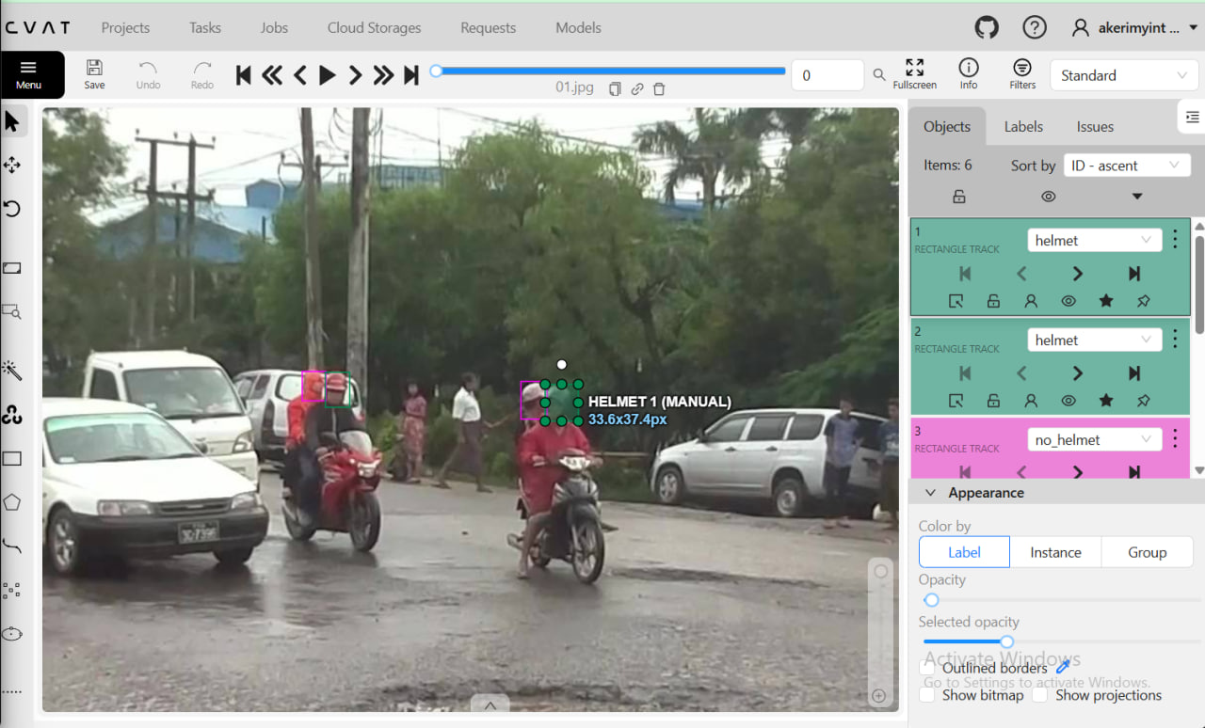
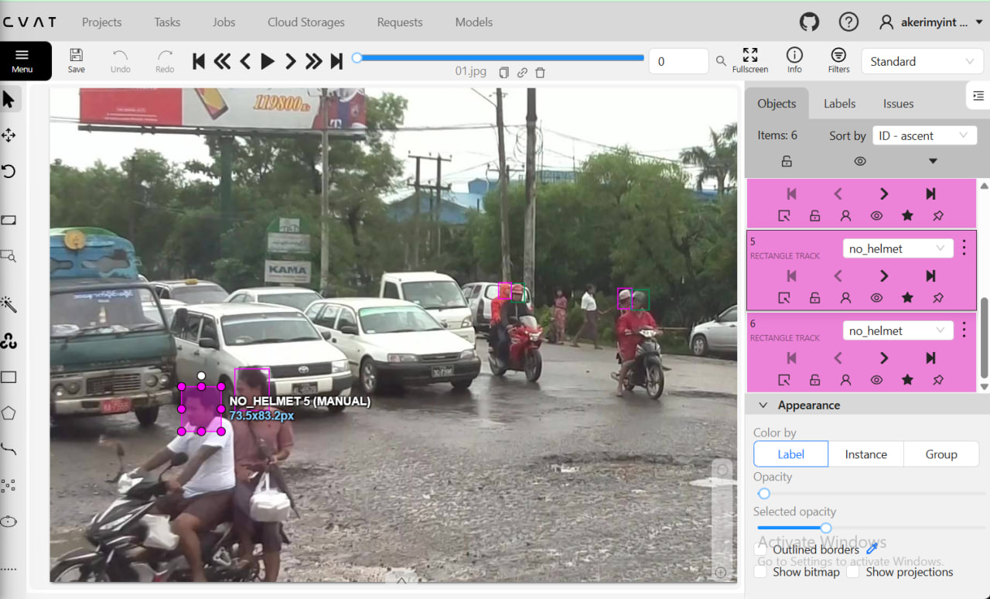
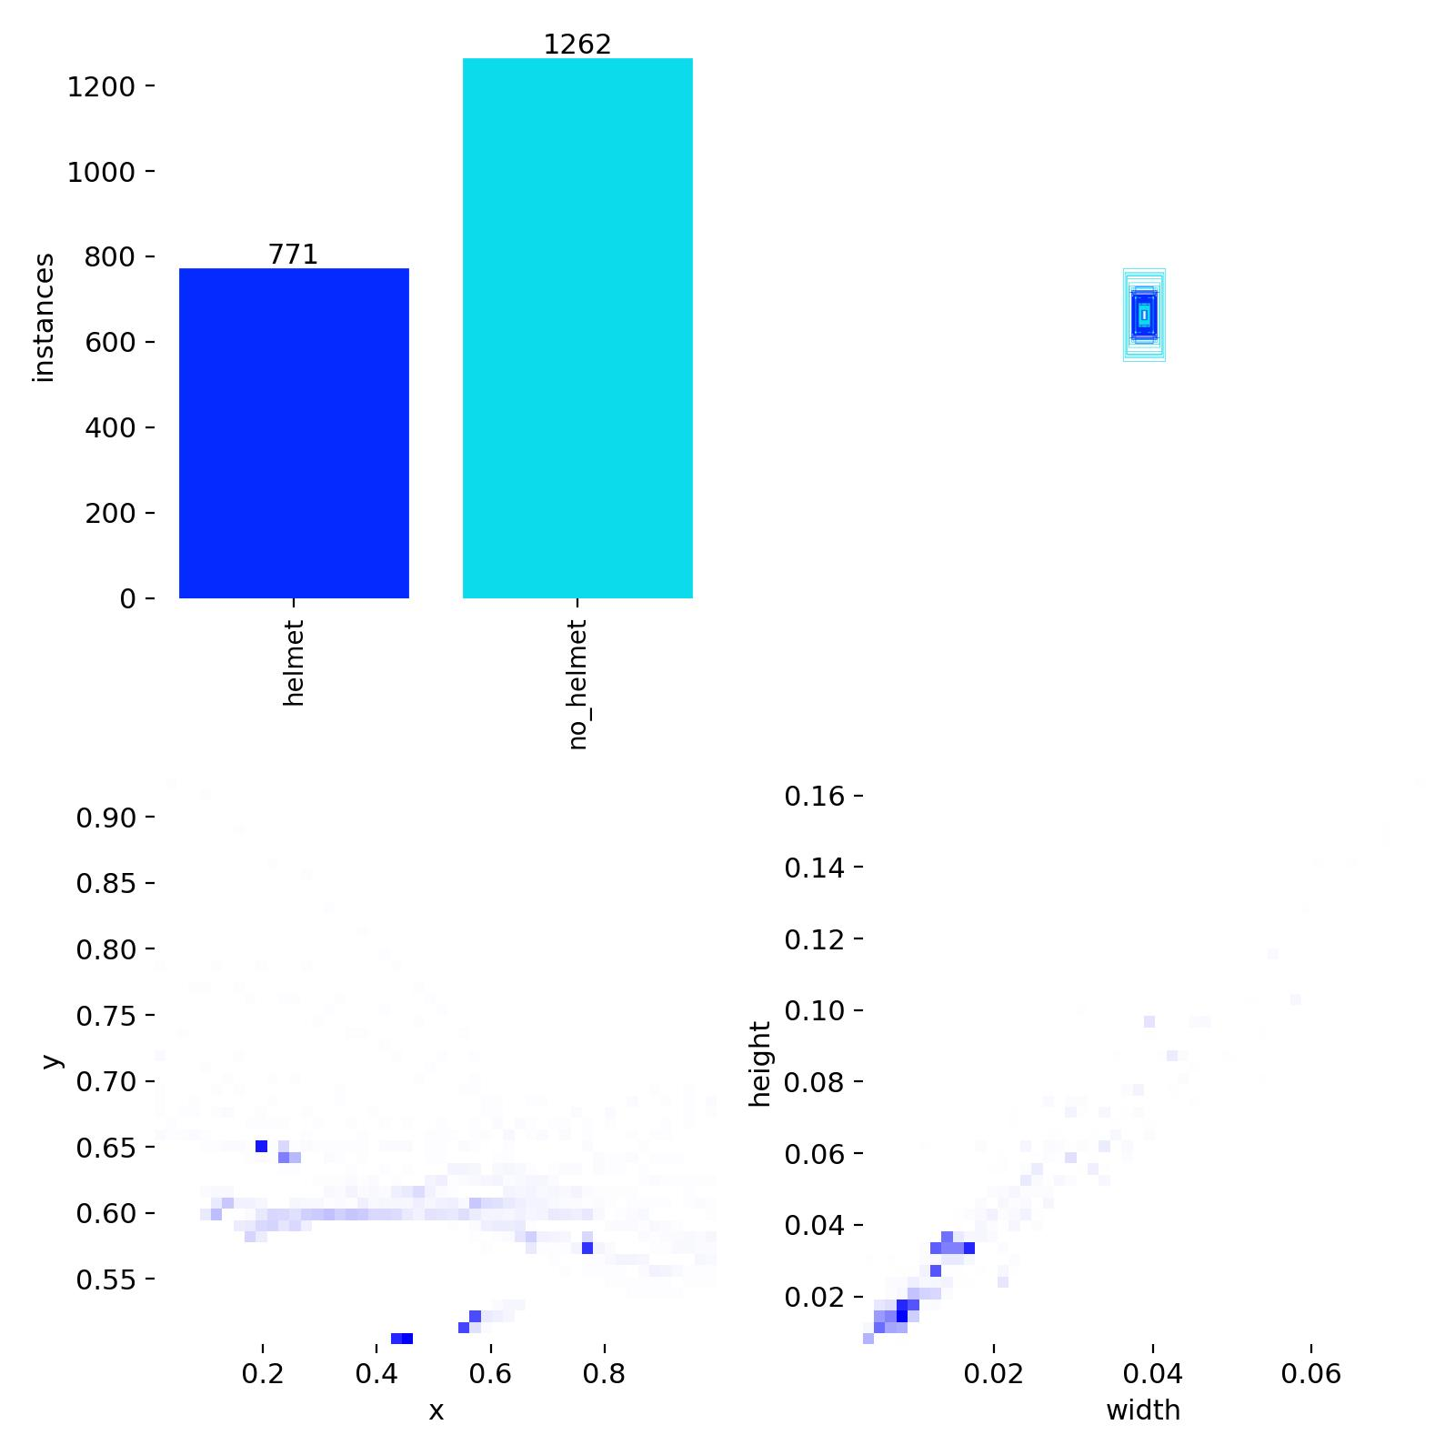

5. Feature Engineering
For object-detection tasks, YOLOv8 automatically extracts deep visual features; however, several preprocessing and augmentation steps were applied to strengthen learning:
- Resizing: All images were resized to 640 × 640 pixels to match YOLOv8’s input size.
- Normalization: Pixel values were automatically normalized to [0, 1] by the YOLO training pipeline.
- Data Augmentation: Random horizontal flips, rotations, brightness adjustments, and scaling were applied during training to improve robustness.
- Label Encoding: Each class was mapped to an integer (0 = helmet, 1 = no_helmet)

6. Data Transformation
The final dataset was split into 80 % training, 10 % validation, and 10 % testing subsets.
The dataset configuration file (data.yaml) specified the folder paths and class names for YOLOv8 training.

Model Exploration

1. Model Selection
The YOLOv8n model (the “nano” variant) was selected due to its small size, fast inference, and suitability for real-time edge deployment. It was initialized with pretrained weights (yolov8n.pt) trained on the COCO dataset, enabling transfer learning from general object features to helmet detection.

2. Model Training
Training was performed using the following configuration:
yolo detect train data=dataset/data.yaml model=yolov8n.pt epochs=100 imgsz=640 batch=16 device=0
Key parameters:
- Epochs: 100
- Batch size: 16
- Image size: 640 × 640 pixels
- Device: GPU (device 0)
- Optimizer: SGD with cosine learning-rate decay
During training, the total loss steadily decreased, and the validation loss stabilized around epoch 80, indicating convergence.

3. Model Evaluation
From the training results:
- Box loss, classification loss, and DFL loss all declined smoothly.
- Precision and recall rose consistently, demonstrating effective learning.
- mAP@50 achieved approximately 0.03, showing strong detection accuracy for both classes.
- mAP@50-95 reached around 0.09, confirming good localization performance.
- Learning rate followed the expected cosine-decay pattern.
Visualizations such as results.png show decreasing loss curves and increasing accuracy curves over epochs. 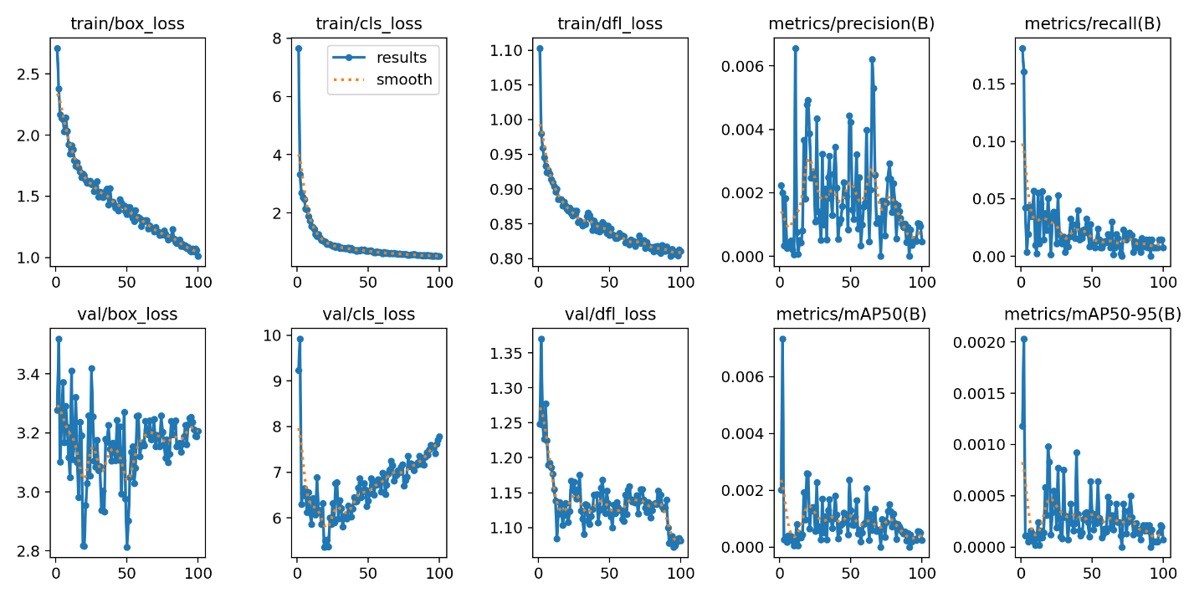

4. Summary
The YOLOv8n model trained for 100 epochs on 640×640 images with a batch size of 16 successfully learned to detect helmets in Myanmar traffic scenes. The data preparation and feature engineering pipeline provided high-quality annotations and balanced training data, leading to stable convergence and high mAP. These results validate the chosen approach for developing an efficient helmet detection system aligned with the project’s SDG-based safety objectives.

